**SVM**

**SVM (Support Vector Machine)** is a powerful supervised machine learning algorithm used for **classification** and **regression** tasks. It works by finding the optimal boundary (hyperplane) that best separates different classes in a dataset.

* It can be Linear or Non-Linear:
  + In 2D, it's a **line**.
  + In 3D, it's a **plane**.
  + In higher dimensions, it's a **hyperplane**.

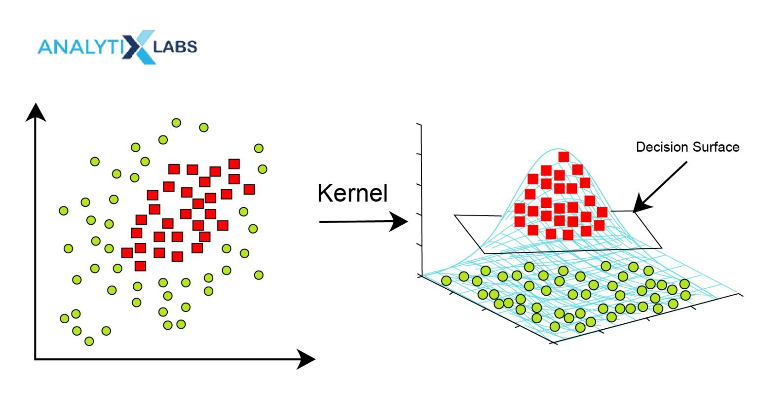

* It **maximizes the margin:**
  + SVM maximizes the distance between the hyperplane and the closest data points (called support vectors).

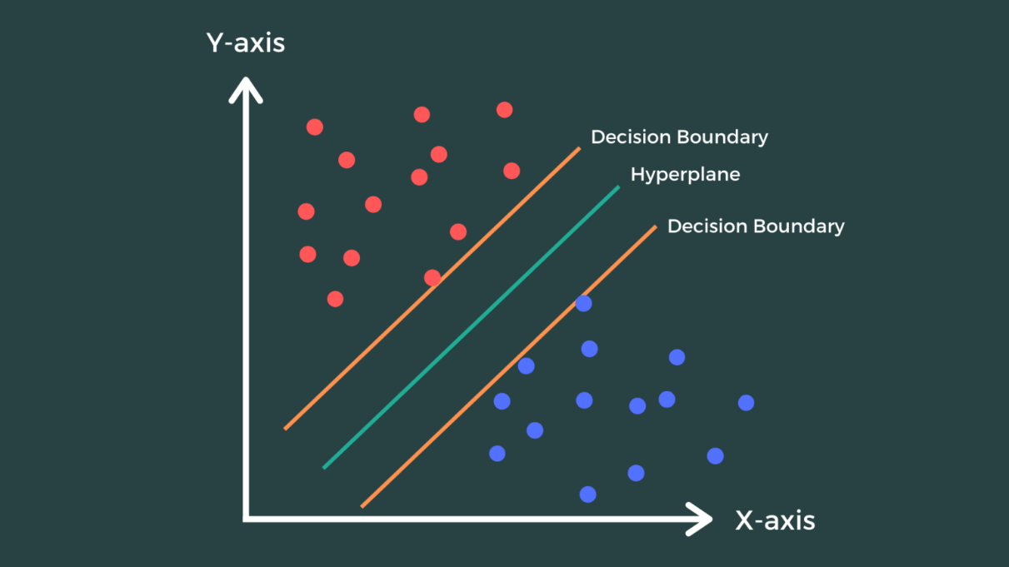

* Steps of SVM:
  + **Data Transformation**: SVM maps the input data into a higher-dimensional space (using a kernel function) to handle non-linear relationships.

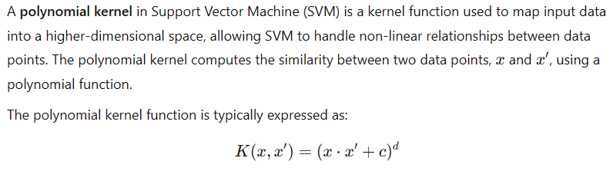

* + **Hyperplane**: It identifies the hyperplane that maximizes the margin (the distance between the closest data points of each class), called support vectors.
  + **Classification/Regression**: New data points are classified or predicted based on which side of the hyperplane they fall on.

